**The Planning Challenge in Iraq**

Prof. Muthar K. Omar Mr. Fu'ad A. Mohammad

SRU, University of Diyala University of Kufa

**Introduction ,**

Searching for the meaning of "Planning" in dictionaries , encyclopedias , and W.W.Web pages comes with amazingly variety in definitions and types of planning . It indicates that "planning" becomes essential for everyday life in advanced societies , and as a way of thinking and doing things to ordinary man. The story is quite differ in less developed and under developed societies . They, may lack of , what could be called , " planning culture" . The term "planning" may be strange to some people , even those who are in charge of public responsibilities . And , it probably makes planning process harder at all stages of plan preparation .This is the crucial point the paper , trying to shed light on and elaborate . We convince that "planning culture" is the underlying cause of most , if not all , challenging factors that confronting planning process in Iraq .

**The problem** ,

The idea of planning in Iraq is so fuzzy that practicing it is considered a dilemma for public and private , common and individual identities . Besides , planners face multi – stage challenges : (1) stating targets and goals ; (2) collecting relevant data ; (3) analyzing data ; (4) drawing alternatives ; (5)evaluating them and choosing one ; (6) implementing the plan ; and (7) monitoring and updating the plan . Each stage of planning process has its own problems and obstacles challenging the planning team . They are :

**Challenges at stage one**

At stage one , a clear cut and precise strategic targets and goals should be stated . But , this may be so difficult due to political conflicts , and vagueness and broad targets sited (if there is any) by central government . This because :

**(1) War destruction ,**

The invasion of Iraq destroys almost every thing . Starting with the regime , then concentrating on destroying "State Infrastructure", and fragmenting society and disorganize it . The undeclared aim , is an attempt to eras Iraq as a state and people from the politics of Middle East.

Many countries suffered from war destruction , and plan to remedy the injuries and recovering the socio-economic status . The case of Iraq may differ and has its own merits . Studying the history and geography of the region , looking at its foreseeable future may give hints to indicate the possible features that needs to be dealt with in planning .

Planning to rebuild a country after a massive destroying war is a hard mission, needs to look at past trends , and the future in political and economic terms, bearing in mind the aspects of ad hog situation. The plan should be flexible enough to absorb and adopt the unexpected , and so firm to stay on truck and achieving the stated targets .

The physical and social environment are polluted by a variety of pollutants . This make the planning process harder , and should be thorough and comprehensive . Besides , dealing with individual local areas separately may not help tackling all problems . Some problems have to be tackled at meso and macro scale . This means , there should be a broad national strategy, implemented by lower scale plans , down to the local urban areas . Planning at this level is disparately in need of social awareness and planning culture , which is doubtfully recognized in the case of Iraq .

**(2) Absence of strategic targets ,**

Although the previous regime had his own Ideology , but it seems that no clear cut strategic targets set out . This may be due to the high centrality norms adopted by the regime . Which by turn , keeps local authorities reacting to the fronting events and actions , waiting orders to act . Initiatives and pioneering actions by local authorities regarded as unacceptable adventures , and setting local goals give the HQ a bad impression .

In other words , there is no strategy , neither previous to 2003 nor after , for both scales : national or local . And this is one of the causes for absence of "planning culture" in Iraq . As democracy is a culture build gradually and had its own price and values , so did the transformation away from centrality , and constructing of a common planning culture .

Regional planning as a toll to solve conflicts between local authorities , and planning projects that’s passes through and serve multi local authorities , is unknown to Iraqi authorities . In Iraq today , each province considered as a region stands for its self with no considerations to nationwide infrastructure , and catchment areas crossing administrative boundaries . Regional planning as a development means is diverted and used to draw political regions according to ethnic criteria . Fragmenting Iraq to ethnic regions , serving outside political goals is another challenge to planning process . So , regional planning has a different meaning in Iraq compared with actual regional planning .

**Challenges at stage two ,**

After stating the ultimate targets and goals for the foreseeable future , looking for the relevant data comes next . At this stage many obstacles face planners . These obstacles are like :

**(3) Lack of recent population census ,**

In 1997 the last official population census was held . Since then , no official records regarding population structure set as acceptable due to political conflicts among leading parties . The population growth ratios in Iraq , in general , and with variety among provinces , show that the trend tend to slow down in particular areas and at certain periods and accelerating in others , according to the political environment in the region and the province . That means planning at meso and micro scale should deal with local merits rather than overall mean . This situation gets worse after 2003 .

**(4) Data reliability ,**

By nature , planning is a decision making process , and the validity of decisions depend on the reliability and accuracy of data . In Iraq today , this is the dilemma . The available data could be :

1. Out of date data collected before 2003 ,
2. Estimations depends on data trends prior 2003 ,
3. Samples collected for political parties purposes ,
4. Personal estimates depends on experience and guess ,
5. Figures stated to convince the boss .

No one of these draw a real picture about the actual situation , and can be used to plan for the next two decades . Here is the challenge , to planner , decision makers , and the scientists .What kind of filtering process to use in order to distinguish between correct and incorrect data ?

**(5) Demographic composition Changes ,**

During the 1980s and 1990s , population turn over took place in many parts of Iraq . After 2003 , aggravated by spatial polarization and in \ out massive migration movements that restructuring the composition of local area population . In other words , the geography of population need to be rediscovered at the micro scale in Iraq in order to plan .

The population pyramid amended during the 1970s , 1980s , 1990s , and dramatically changes after the invasion . This put the planner in a puzzling situation . He cant depend on previous population trend , and has no reliable data at hand . The local authorities still depend on the central government estimations . Most of such estimation abstracted from previous trends and corrected according to personal judgments . Sampling procedures could help , but still not reliable enough to plan for 20 to 30 years ahead . People response with caution to surveys , especially when many parties collecting data for their purposes at the same time .

**Challenge at stages three ,**

The analyzing team should comprehend the mentioned challenges , and keeping them in mind , and connect them with the coming ones .

**Challenge at stages four and five ,**

Drawing future scenarios and evaluate them , amend them according to sponsored authority view gives the planning team a sharp headache . The team should discus every details with the other party and convince them . The challenge isn't easy at this stage .

**(6) Lack of planning education and practice ,**

The sole Institute for Urban and Regional Planning in Iraq was established late 1960s , giving post graduate meta-disciplinary courses . Most of its graduates carry on their study and have Ph.D. degrees from abroad universities. Some of them rejoin the Institute as lecturing staff , others go back to their original background education , and few of them join planning authorities at the province level . This means that those who are qualified in planning , and practice as professional planners are so few . Planning isn't just an education , it is a professional practice . And , that’s one of the key factors affecting planning system in its most crucial components .

The paper considers the "Lack of planning culture" as the main cause for planning failure in Iraq . Planning culture looked as an educational bases that guide behavior of both practitioners and public . Lacking this knowledge and practice leads to reactions rather than positive response in solving problems . Reactions are , usually , emotional by nature not bound to strategic targets .

**Challenges at stage six and seven**

Planning is meaningless unless implemented completely and achieving the plan targets . Updating the plan to acclimatize with unexpected events need well trained planners . But who will do that ? Qualified for the job or not? And many other questions raised in our case study .

**(7) Local authorities and planning ,**

Planning at local authorities , chaired by persons with B.Sc. degrees in surveying or civil engineering . Their own duties restricted to "development control" not to planning participations . Precisely , they act as "gate keeper" , allowing and preventing land use applications according to the Master Plan of the city . Anybody with intermediate school certificate can do such study .

Moreover , Master Plan , itself is not respected and committed by decision makers , so they push "gate keepers" to allow unacceptable uses in zones designated to other uses . The results , divergence from the plan gradually . Besides , Master Plan is regarded as a heavy obstacle facing personal wishes of many of those at province authority .

**(8) Restless security situation ,**

The war creates an environ that helps gangs to control streets and areas , all over Iraq . Some of these gangs wear a "Militia" dresses and act as political forces. What so ever the backing party , they accomplish what the invaders did. They achieve the second stage mission in destroying Iraq . The results , frightened people , no matter what their religion or ethnic group or Islamic division . Fear is one of the common feelings across the nation .

Surviving is the sole hope people can think about during such situation. So , they move to places where they thought they will find peace and help . In other words , a socio-political polarization took place to deepen the barriers between people . Preparing for the third stage they plan to "Dividing Iraq to sub-regions" .

The restless security situation does not encourage investors to invest in long term production activities . Instead , consumption goods and short term production activities are the available alternative . These activities do not construct an economic bases to plan for a prosperous nation . This is another planning obstacle , planning to what ? Keeping the situation as it is ? Or push it a little bit ahead ? Or plan for dramatic changes and help to re- build the country with strong economy ? Planning for unified Iraq ? Or a country divided to sub-regions ? Planning for individual town as an administrative centre ? Neglecting what's going on at its adjacent region ? Taking what local people hope and wish as an ultimate target ? Or the target that stated by province authority ? Do elected authority for four years has the right to decide the future for the next twenty years ? Who really knows what is going to be in the near future and determines it ? Local people ? Local authority ? Central government ? Others ? Well known that the only permanent thing is "change" , what kind of changes have to be dealt with and plan for ? That is the dilemma .

These are the common obstacles and challenges confronting planning team . The team may face other challenges related to local area properties . It was said that there is no twin cities , each town or city stands for its own characteristics . The next section of the paper will shed light on "Al-Najaf" city as a case study presenting some of the mentioned above challenges .

**Al-Najaf City as a Case study ,**

Al-Najaf is an Islamic holly city , located at the conjunction of longitude 44.19 east and latitude 31.59 north . Visitors come from around the world , especially Iran .Its population in 1947 (56261) , raised to (381486) in 1997, that's (6.781)times in fifty years . Looking at this finding in more detail , it looks like that the city gain (9312) people per year . This is for the long term (50 years) , but it is fluctuated during the period and ranged between (3239) to (14038) people according to the political situation in the region . Table (1) shows these findings .

Table 1

Al-Najaf population : 1947 – 2007*

|  |  |  |
| --- | --- | --- |
| year | population | Annual increase |
| 1947 | 56261 |  |
| 1957 | 89190 | 3293 |
| 1965 | 134027 | 5605 |
| 1977 | 186479 | 4371 |
| 1987 | 304832 | 11835 |
| 1997 | 381486 | 7665 |
| 2007 | 521864 | 14038 |

* 2007 estimation , others census results

The holiness of the city comes from the shrine of "Emam Ali Ben Abi Taleb" , his Mosque , and Its cemetery . Nearby are Al-Kufa town and Kerbala City . The three settlements together make a polarization centre attracting people to visit and to live near . Map (1) represents the land use in Al-Najaf city in 2010 .

Three Master plans were designed to the city , first one issued by Doxiadis Association in 1958 [1], the second by Ministry of Municipalities in 1973 , and the third one by Ministry of Planning in 1976 . The percentages of land uses according to these three Master Plans presented by table 2 below .

Figure 1

Land use in Al-Najaf City 2010

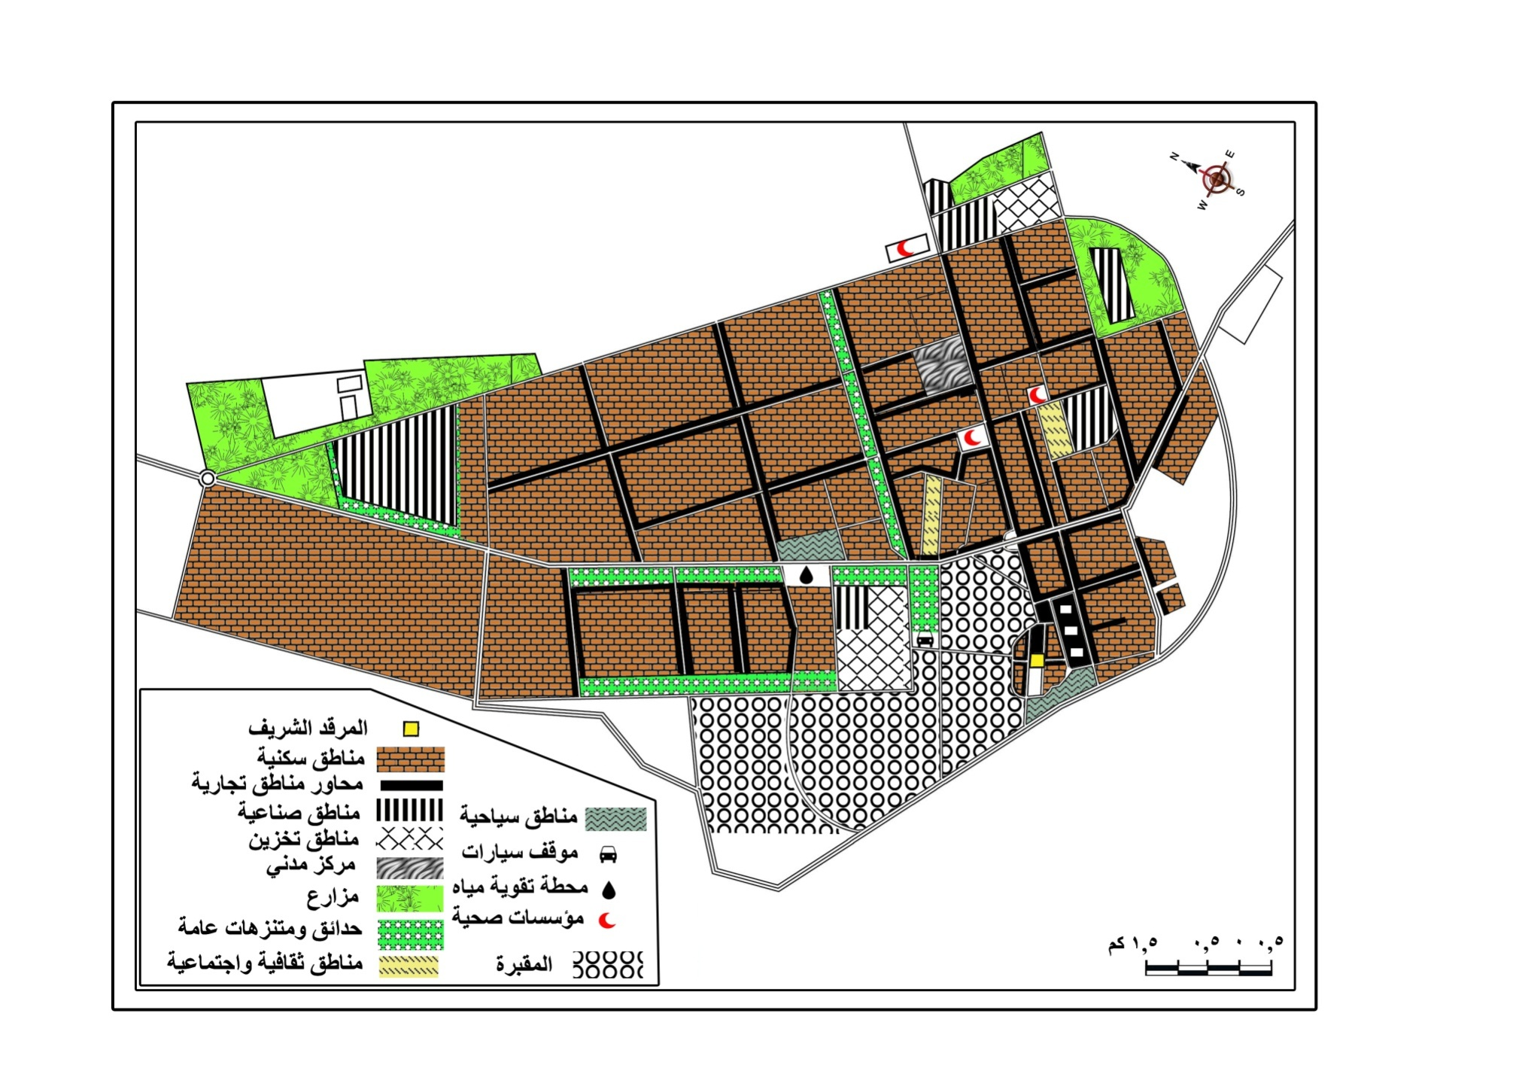

Table (2)

Land use allocation according to Master Plan   
of Al-Najaf City[2]

|  |  |  |  |  |  |  |
| --- | --- | --- | --- | --- | --- | --- |
|  | 1958 Plan | | 1973 Plan | | 1976 Plan | |
| Area Hectar | % | Area Hectar | % | Area Hectar | % |
| Residence | 1500 | 37.5 | 1160 | 54.71 | 2871.46 | 44.16 |
| Commerce | 250 | 6.25 | 30 | 1.41 | 178.94 | 2.75 |
| Industry | 450 | 11.25 | 87 | 4.1 | 560.8 | 8.62 |
| Transport | 1000 | 25 | 580 | 27.35 | 1232.48 | 18.96 |
| Public utilities | 800 | 20 | 230 | 10.84 | 274.53 | 4.22 |
| Green & Open |  |  |  |  | 846.61 | 13.02 |
| Admin. uses |  |  | 33 | 1.55 | 162.7 | 2.5 |
| Touristic areas |  |  |  |  | 107.72 | 1.65 |
| Vacant |  |  |  |  | 264.4 | 4.06 |
| Total | 4000 | 100 | 2120 | 100 | 6500 | 100 |

* Hectar = 10,000 sq.meter

**Causes for Master Plan Failure ,**

The first Master Plan is criticized for the ignorance of the religious importance of the city and its character , had no indication to preserve architectural heritage , and does not account for the arid climate of the area . The second plan failed to fulfill the designated green areas within the built up area and the type of recreation accompanied it . Beside that , it follows the previous plan 's view and land use estimations .

The third plan , after (14) years , only (67%) of it implemented due to incorrect estimations of land uses and locations needed for the time span . Moreover , the allocated residential land use had been allocated (100%) one year before the end of the stated period . The plan does not cover the whole area with sewage system . It seems that , most Master plans at this period do not depend on accurate field survey data , and their suggestion does not present a comprehensive development plan . [3]

The Centre for Urban and Regional Studies which considers the failure to implement Master Plans as a scientific problem has to be investigated by his students and staff . The main points mentioned by their studies are :

1. Centrality of decision making , due to the number of qualified persons in planning , and the overall governmental policy . Many issues at the remote urban areas was not recognized by those at the central planning team . Instead , judgments were taken depending on false data or inadequate sampling procedures . [4]
2. Although Iraq rich by its natural resources , but the utilization and allocation of the return of these resources to public services and development activities are considered as great obstacle to planning process . [5]
3. Lack of co-ordination channels between governmental departments , at both levels : central and local make planning process extremely hard from the first stage to the end . [6]
4. Marginalized public participation due to centralized plan preparation and political and technocrats points of view . Public participation is considered by planning theorists as a key factor to let public understand what is going on and why, and to encourage them to co-operate .[7]

Al-Najaf witness a rapid land use changes post 1990 . Fu'ad studied these changes and found that they wave like in their pattern . The total commercial uses take over residential uses during the period (1990 – 2010) are (7687) cases , and (2394) industrial uses take over residential use . These changes spread over (40) neighborhoods, changing land use structure and shopping trip (at least) . The pattern and trend of such changes , should be kept in mind when plan to update the Master Plan of the city . This means that collecting data about the ad hoc situation is not enough to plan for future . Changes in adopted technology and community life had its reflections on land use . So , the changes in urban fabric and their trends make another challenge to planning processes , they should be explored and considered deeply .

**What's next ?**

In order to develop and achieve progress , planning is the ultimate way to do so . And to make planning work , the mentioned challenging obstacles should be dealt with first . But priorities have to be arranged first , the most common and crucial has to gain the first order . We believe that "planning culture" comes across most of the mentioned challenges , and act as a base and guide to decision making at various levels . So , the raised question is : how to establish such a base to local authorities and public ? The answer may be by achieving one or more of the following suggestions .

1. Expand old planning institutes and establish new ones across the country , especially as interdisciplinary undergraduate courses .
2. Organize post graduate planning courses at departments of : Law , Ecology , Geography , Civil Engineering , Economy , Administration , Sociology , and community services .
3. Organize post graduate multi disciplinary courses , at the university level passing over departmental restrictions (Post graduate studies College).
4. Organize non-certificate courses for those involved in planning and not allowing to carry on further studies .
5. Organize sandwich training courses for those involved in planning at local authorities .
6. Set out a monitoring system to check the process of implementing Master Plans .
7. Review and update planning regulations and laws according to the recent situation and raising matters .
8. Plan for deploying planning culture across the country and among society .

1. Iraq Ministry of Planning , Development Board , Doxiadis Associates Consulting , The future of Najaf and Kufa , 1958
2. الجبوري ، فؤاد عبد الله محمد ، تحليل جغرافي للتغيرات الوظيفية ضمن البنية العمرانية لمدينة النجف الاشرف ما بعد 1990 ، أطروحة دكتوراه ، (غير منشورة) ، جامعة الكوفة ، 2011
3. الشماع ، احمد ناطق محمد علي ، التوجهات التخطيطية المطلوبة بين الأصالة والمعاصرة للبنية الحضرية لمدينة بغداد ، منطقة الدراسة – عرصات الهندية ، رسالة ماجستير (غير منشوره) مركز التخطيط الحضري والإقليمي ، جامعة بغداد ، 2002
4. حسون ، ضياء وفيق ، الاسناد التخطيطي لمتخذي القرار باستخدام نظم المعلومات الجغرافية ، إطروحة دكتوراه (غير منشورة) ، المعهد العالي للتخطيط الحضري والاقليمي ، جامعة بغداد ، 2005
5. محمد ، اوس محمود ، دور مصادر التمويل في التخطيط وادارة الخدمات البلدية في مدينة بغداد ، رسالة ماجستير (غير منشورة) ، المعهد العالي للتخطيط الحضري والاقليمي ، جامعة بغداد ، 2010
6. الفتلي ، باسل احمد خلف ، تقويم تنفيذ التصميم الاساس لمدينة الحلة ، أطروحة دكتوراه ، مركز التخطيط الحضري والاقليمي ، جامعة بغداد ، 1998
7. الزبيدي ، نجوى عبيد عجمي ، المعايير التخطيطية للمساحات المفتوحة والخضراء في مدينة بغداد ، رسالة ماجستير (غير منشورة) ، المعهد العالي للتخطيط الحضري والاقليمي ، جامعة بغداد ، 2005